 |  | 

CONDITION BASED ASSESSMENT
QUICK SCANNING REPORT
SBUM DIAGNOSTIC JOHOR
TNB BAHAGIAN PEMBAHAGIAN JOHOR

FUNCTIONAL LOCATION (ERMS) | : | JJBU/PCE/K00191
FUNCTIONAL LOCATION (SITE) | : | JJBU/PCE/K00191
SUBSTATION NAME (ERMS) | : | O/D KG MAJU JAYA NO.1
SUBSTATION NAME (SITE) | : | PE O/DOOR KG MAJU JAYA # 1
COORDINATE | : | 1.583366, 103.718120
SUBSTATION TYPE | : | PCE
AREA | : | JOHOR BAHRU
STATE | : | JOHOR
PO | : | 42234207
DATE | : | 14 JUL 2026
SCANNED BY
THERMOGRAPHY | : | MUHAMMAD OMAR RIDZUAN (2013MY20N010)
EQUIPMENT/TOOLS
THERMOGRAPHY | : | FLIR T640 (SN 55912229) (CALIBRATION DUE DATE: 26 DEC 2026)
PREPARED BY
NAME OF CONTRACTOR | : | EET ENGINEERING SERVICES SDN BHD
ADDRESS | : | NO.38, JALAN SS19/1D,
 | : | 47500, SUBANG JAYA, SELANGOR.
SUBSTATION SIGNBOARD
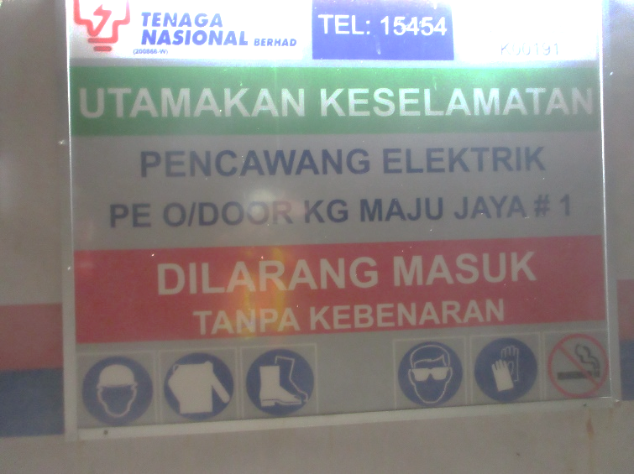

visual defect Summary
NO. | EQUIPMENT | DEFECT DESCRIPTION | ELECTRICAL | NON-ELECTRICAL
1 | RUBBER MAT | NO RUBBER MAT |  | X

SUBSTATION CONDITION

SUBSTATION OVERVIEW |  | SIGNBOARD
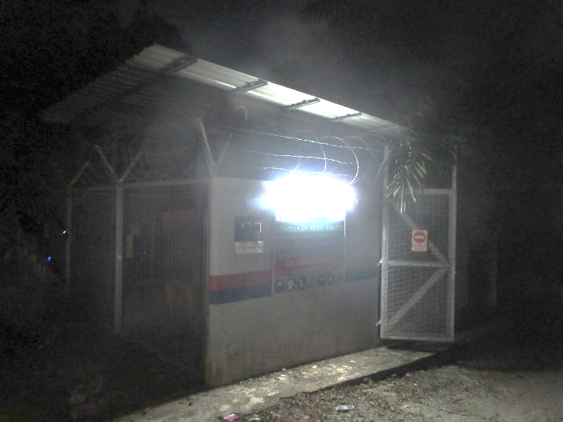 |  | 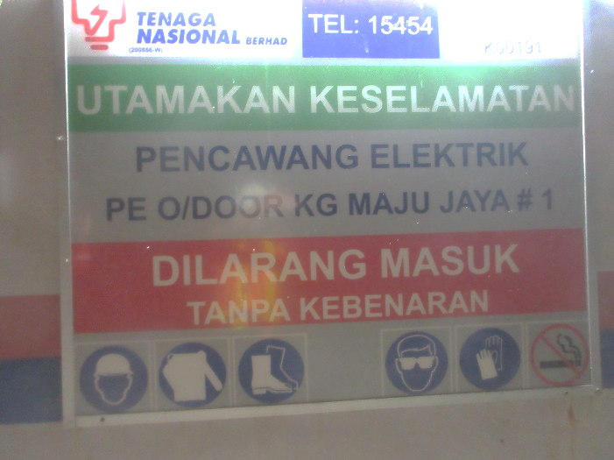
SWITCHGEAR |  | SWITCHGEAR NAMEPLATE
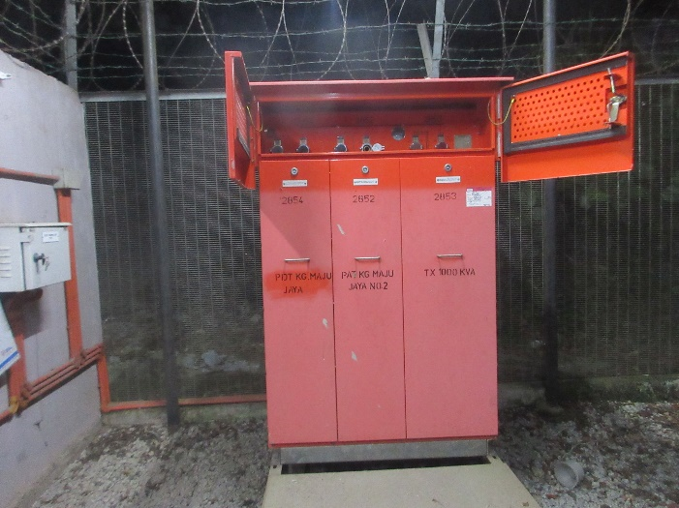 |  | 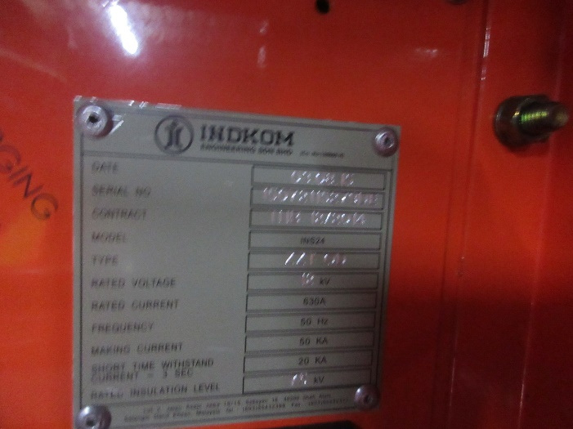
TRANSFORMER 1 |  | TRANSFORMER 1 NAMEPLATE
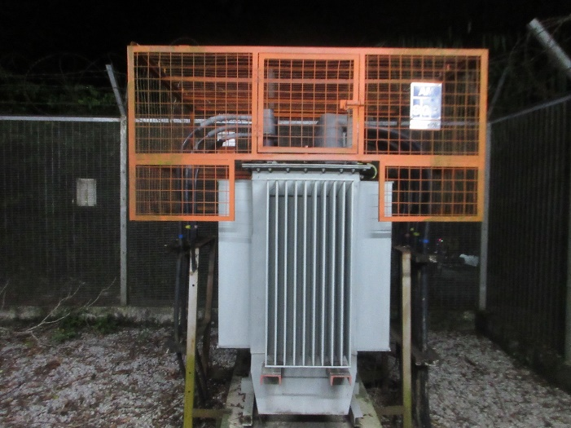 |  | 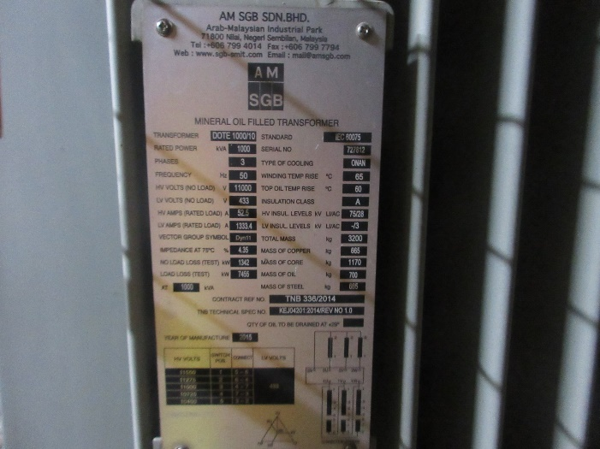

SUBSTATION CONDITION

TRANSFORMER 2 |  | TRANSFORMER 2 NAMEPLATE
N/A |  | N/A
FEEDER PILLAR TX1 |  | FEEDER PILLAR TX1 NAMEPLATE
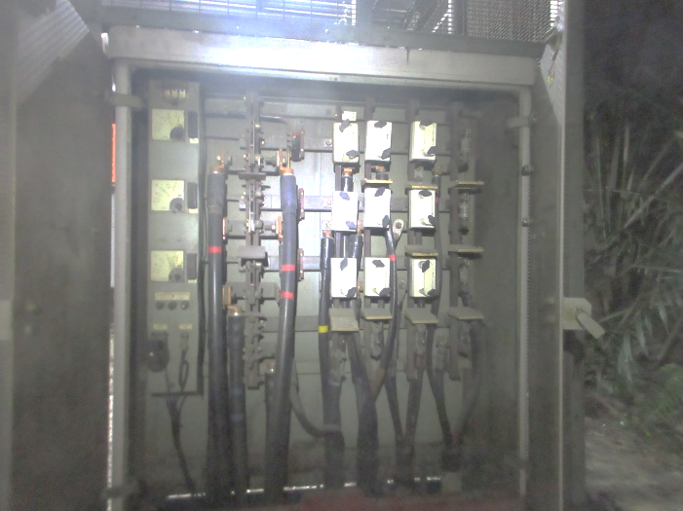 |  | N/A
FEEDER PILLAR TX2 |  | FEEDER PILLAR TX2 NAMEPLATE
N/A |  | N/A
SUBSTATION CONDITION

EFI |  | SF6 INDICATOR
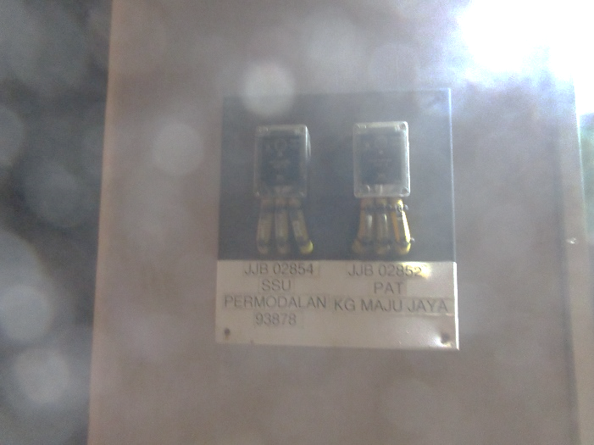 |  | 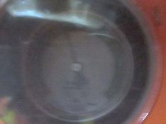
BATTERY |  | BATTERY NAMEPLATE
N/A |  | N/A
FIRE EXTINGUISHER |  | FIRE EXTINGUISHER NAMEPLATE
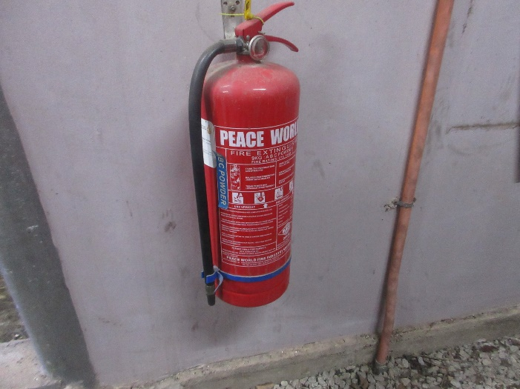 |  | 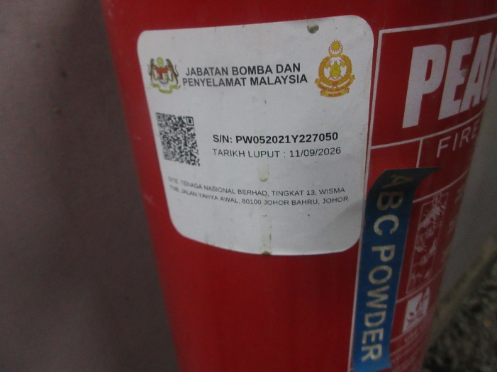

SUBSTATION CONDITION

SWITCHGEAR PANEL NAME |  | LAST PREVENTIVE MAINTENANCE
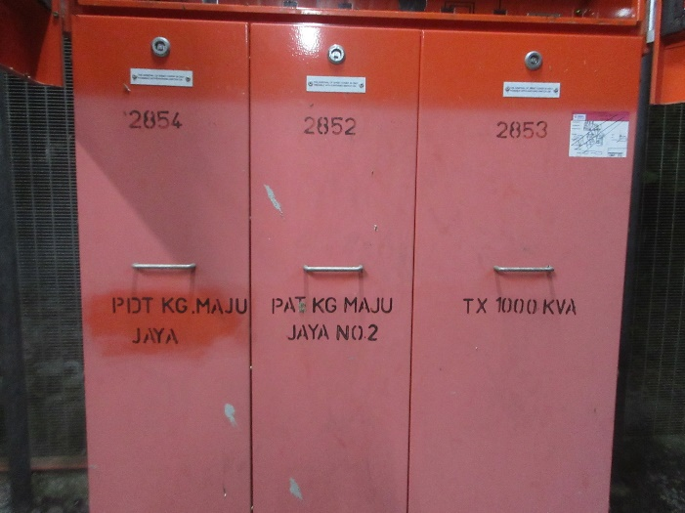 |  | 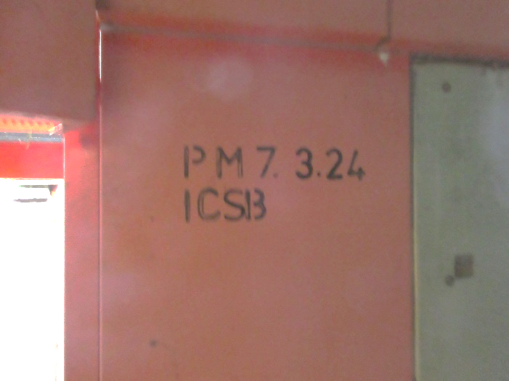

VISUAL DEFECT

RUBBER MAT
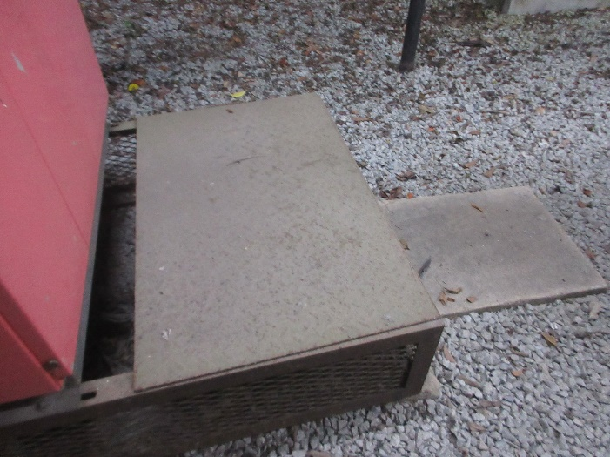
NO RUBBER MAT

NORMAL/DEFECT STICKER

NORMAL STICKER
